**Phil Murphy’s Tax Credit Plan for New Jersey’s AI Economy:**

**Growth Implications and Tradeoffs**

Krishna Meegada, *Bentley University*

Tanuj Chandekar, *Indiana University – Kelley School of Business*

**1. Introduction**

Artificial Intelligence (AI) has become a buzzword, and it seems like every entity is trying to incorporate it into their operations. New Jersey has not been slow to capitalize on the “AI Revolution” either. Governor Phil Murphy signed a sweeping new bill in July 2025, expanding previous innovation tax credits, hoping to attract AI development to the state. In doing so, New Jersey becomes the only state in the United States to issue an AI specific tax credit.

1.1 Specifications of Programs

Murphy’s gubernatorial term has revolved around attracting the most technologically innovative companies to the state, introducing broad tax breaks to attract these companies. Starting in July 2024, Murphy signed the Next New Jersey Program Act, which incentivized Artificial Intelligence companies to do business in the state. It’s important to note that while this was signed into law in 2024, applications opened in June 2025, so there will be a lag for when the credits will be issued and when the budgetary effects can be measured.

Here is a breakdown of the program:

Table 1.

|  |  |
| --- | --- |
| Next New Jersey Program Act (NNJPA) | |
| Eligibility | $100 million in capital investment |
| Creates no fewer than 100 jobs |
| Each job must be paid 120% of the county median salary |
| The business must enter a partnership with a New Jersey–based public or private university, technology startup, incubator or accelerator |
| More than 50% of the employees must be engaged with AI related activities OR more than 50% of the company’s revenue is generated from AI activities |
| Awards | Each new job gets the awardee an additional .1% of its total capital investment back.  This is capped at the lesser of:   1. 25% of the business’ total capital investment 2. .1% of their capital investment multiplied by the number of new full-time jobs created 3. $250 million |
| Source of Funding | $500 million allocated from Aspire and Emerge |

In July 2025, Murphy signed legislation that left the NNJPA untouched but updated the Angel Investor Tax Credit Act (AITC) and the New Jersey Innovation Evergreen Fund Act (NJIEF), while repealing the NJ Ignite Program. While the 2025 bills weren’t directly intended for AI based businesses, the expansion of the programs mentioned has a direct impact on the sector.

Introduced in 2013 under former governor Chris Christie, the AITC was intended to encourage investment in “emerging technology businesses”.[1] In essence, it allows corporations or individuals who invest in emerging technology businesses to reduce their tax liability by a percentage of their investment. Specifics on the program and updates to it are listed in Table 2.

Table 2.

|  |  |
| --- | --- |
| New Jersey Angel Investor Tax Credit (AITC)[2] | |
| Business Criteria | The business must employ fewer than 225 full-time employees, at least 75% of whom work in New Jersey |
| They must either incur qualified research expenses conduct pilot scale manufacturing, or commercialize eligible technologies (full list available on the NJEDA website) |
| Their primary business must be an eligible technology |
| Investment Criteria | Non-refundable transfers of cash made directly to the qualified business |
| Changes to Awards as of 2025 | Increases the tax credit from 20% to 35% on qualified investments plus an additional 5% for opportunity zone/low-income community/minority or women owned businesses |
| Changes to Funding as of 2025 | Decreases the total cap on credits awarded from $35 million to $25 million |
| Unused credits from the NOL Program can be allocated to AITC |

The NJIEF was instated at the start of Murphy’s term in 2018, providing a framework for the state to be a middleman in the funding process of startups. Here is an explanation of the program taken directly from the NJEDA website: “The Evergreen Program will secure funding and strategic support from the sale of state corporate tax credits in a competitive auction, then partner with private venture capital firms to co-invest the funds in eligible early-stage businesses in New Jersey.[3]” It’s worth noting that, of the six companies listed as qualified investment, only one is a company that utilizes AI in its main product, and it partnered with the NJIEF in 2023, before the signing of the NNJPA.[4]

The eligibility criteria for the auction process, venture firm, and qualified investment are lengthy and technical, and not useful for the scope of our article. However, the changes to their award and funding size are relevant. The new bill increases the size of eligible investments from $5 million to $10 million. For certain New Jersey university developed intellectual property, minority and women owned businesses, it increases from $6.25 million to $12.5 million. It also gives the state the ability to conduct additional tax credit auctions. The annual issuance of this credit is not allowed to exceed $60 million.

It's extremely important to understand that while all three of these programs increase capital available to the AI sector, they do so in quite distinct ways.

1.2 Thesis, Limitations, and Rationale

In this article, we hope to understand the growth implications of the 2024 NNJPA, as well as the subsequent 2025 updates to the NJIEF and AITC, to the extent that they pertain to the AI sector of New Jersey’s innovation economy. This will be done through thorough analysis of the New Jersey Economic Development Authority’s (NJEDA) and New Jersey Division of Taxation’s (DOT) annual reports as well as the New Jersey Office of Legislative Services’ (OLS) monthly revenue snapshots and annual outlooks.

We recognize that there are various programs that influence the innovation economy, like the Aspire, Emerge, and Technology Business Tax Certificate Transfer (NOL) Programs. However, in this article, we want to focus on the NJIEF, NNJP, and AITC programs because we believe these are the most relevant tax credits to the artificial intelligence sector of the innovation economy.

We believe that this article is extremely useful for New Jersey residents, policy makers, and government officials. Analyzing these credits through a data driven approach, supplemented by economic theory, will give insight into employment growth, business formation, and long-term fiscal sustainability. These will prove especially important as New Jersey approaches a gubernatorial election, where economic innovation policy will be a central issue.

**2. Growth Implications**

2.1 Increase in Capital Investment

In general, when tax credits are given to a business, it’s analogous to companies subsidizing their business activities. However, with the restrictions placed on obtaining certain credits, they can incentivize and disincentivize certain behaviors. With the introduction of the NNJPA, and further expansions of the AITC and NJIEF, companies either receiving the credit (NNJPA) or the investment (AITC & NJIEF), will increase the financial resources they have on hand.

With the promise of additional financial resources, companies will be attracted to incorporate or do business in New Jersey. In addition to economic incentives, AI companies need to move to a place with an appropriate environment. This means access to a qualified workforce, proximity to clients, innovation infrastructure, and actual adoption of AI tools. A recent report from The Brookings Institution analyzes the AI readiness of regions across the country, with the three distinct metro areas of New Jersey (New York/Philadelphia Metro and Princeton areas) given the second highest rating.[5] Furthermore, the state also benefits from top research institutions, highlighted by the NJ AI Hub being launched in conjunction with Princeton University and Microsoft.[6]

Given this environment, it’s not a surprise that New Jersey has a massive Data Center market. Commercial Cafe, a trusted commercial real estate news and reporting website, ranked the state as the fourth highest in the Data Center inventory market.[7] In the year following Murphy signing the NNJPA, there have been 3 high value deals, collectively worth around $2 billion, that have brought AI activity to the state.[8] [9] [10]

Figure 1.

It’s clear that New Jersey has the correct environment in place for companies to move in, and the major deals cited above have proven this. Figure 1 illustrates trends in the general business and corporation applications for the state. It’s important to clarify that corporate applications are a subset of general business applications. Also, this data is not seasonally adjusted. However, since the growth rates are reported as year-over-year percent changes, it ensures valid comparison over time. In the time after the signing of the NNJPA, business applications have trended positively compared to the year before, mostly due to a massive uptick in corporate applications. Even with corporate tax rates up to 11.5%, the highest of all 50 states, C - Corp applications are still on the rise.

It’s important to understand that the NNJPA alone did not cause this increase, and these applications may be for a variety of different businesses in different industries. New Jersey’s generous R&D, Net Operating Loss tax credits, and various other business friendly reforms being put into place alongside the AI tax credit have cultivated an environment for corporations to move to.

This upward trend potentially signals increased economic activity for the state economy, as C – Corps are usually much larger businesses because they require much higher administrative costs than other forms of business. On average, they are associated with higher pay and stable jobs, while their growth means increased Corporate Business Tax Revenue. In line with economic theory, big corporations, especially in the technology and AI sector tend to increase Total Factor Productivity (TFP). This measures the portion of output growth not explained by increases in the quantity of labor or capital inputs. TFP growth implies an increase in the efficiency of these inputs, meaning that both capital and labor can increase their output, without increasing their quantities.

In essence, the promise of future credit for the AI sector along with business-friendly expansions in other credits may have bolstered business confidence, and increased C – Corp applications, therefore, leading to increased stimulation into the state economy.

2.2 Inequal Growth

However, while the economy itself may be more efficient and productive as a result of the credits, the growth may not be shared equally. The most striking example of disparity that may occur is within the labor force.

Figure 2.

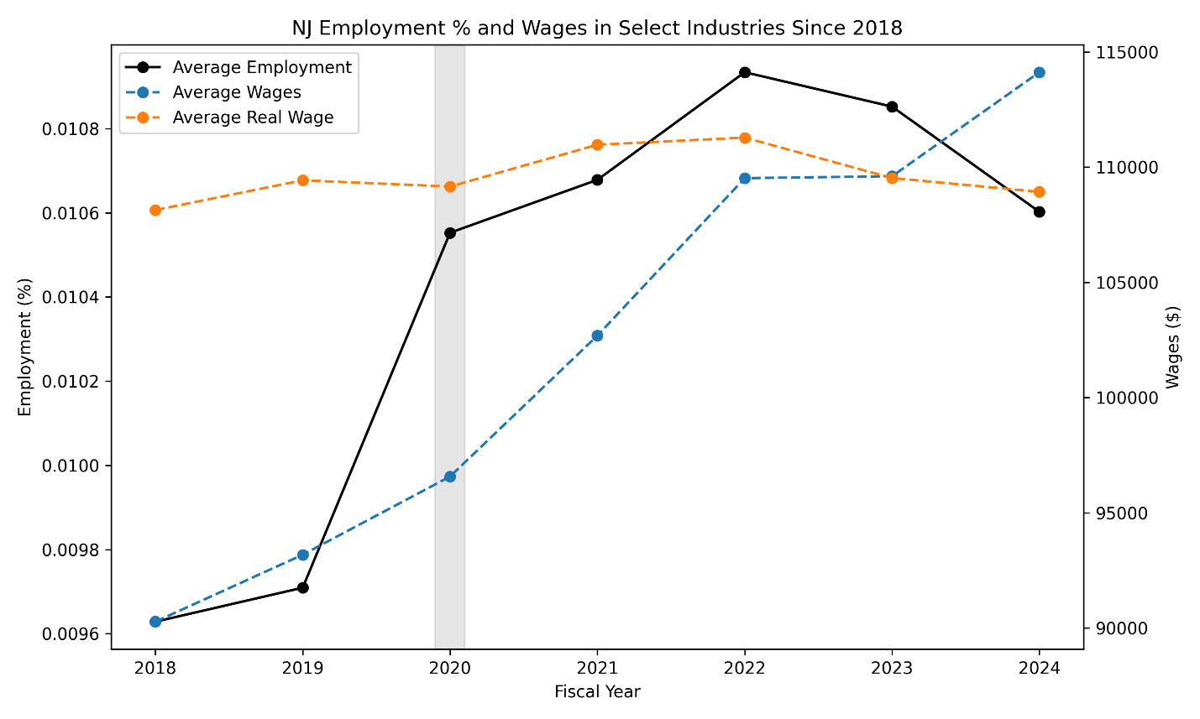

Figure 2 shows the employment rate as well as the nominal and real wage growth in select industries from the start of Murphy’s term. We selected this basket of industries and subsectors because we believe they are directly related to AI companies.[11] It’s also important to note that this timeframe is before the expansion of the NJIEF and AITC programs as well as the introduction of the NNJPA. However, we believe that it’s important to understand the existing trends to extrapolate how these credits play a part in furthering the development of employment and wage growth in the sector.

From 2018 – 2024, the average employment increased by around 10% while real wages only grew by around .7%. In other words, companies have increased output since they are able to hire more workers, but, in real terms, are not paying them more. It’s important to note that we are denoting real wages, so companies may raise the employees' nominal wages, but they may not actually be earning more due to an increasing price level.

A myriad of factors could explain this occurrence, like the high inflation period and an expanding labor force immediately after the pandemic. However, alongside these factors, it could suggest that, in these industries, the return to capital is higher than the return to labor. Higher returns to capital means that companies may believe that “AI capital” (like computers, software, data centers) are the drivers of real growth. This also suggests diminishing marginal returns on labor because each additional worker hired may add less value, so they are not being paid more. This logic adheres to the convention of capital-intensive industries like advanced computing or artificial intelligence.[12] [13]

Given this existing trend, the introduction of the AI tax may only serve to exacerbate the trend of stagnant real wage growth. This is because the tax credit will increase investments into the company, whether directly or indirectly, dependent on the program. Thus, allowing them to increase their output, but most of that growth would be driven by “AI Capital” as opposed to labor. For each dollar they put into improving their AI product, the less valuable it is to pay each additional worker more money.

However, the guardrails put in place for the credit seem to make sure that employers are forced to pay workers fair wages, as opposed to stagnation.

Nonetheless, companies are able to find loopholes to get around these guardrails. For a company to qualify to receive the NNJPA, they are forced to pay employees 120% of the county median salary. Although this may be the case, there is nothing stopping companies from operating out of low-income counties. For example, Camden’s median income is around $40,000, so this means employees would only have to be paid $48,000. Companies will be able to steadily stagnate or decrease their workers’ real wages as the output produced from the credit reward goes to capital infrastructure or profit for their shareholders. This is a clear example of horizontal inequality[14], where similarly skilled workers will be getting paid differently because of where they may be located geographically.

Furthermore, Artificial Intelligence companies need a specialized workforce, as mentioned in the Brookings report above. This usually means that higher skilled workers will be coming from higher income communities, as most research suggests a link between higher income and education. This may not give the workers in the local, low-income community a chance because they don’t have the skillset needed to work in these specialized jobs. While companies still need lower skill labor for other functions, a majority of their workforce will be highly specialized. In essence, the AI credit may disproportionately favor higher income, highly talented workers in non-distressed communities, which may further worsen vertical income inequality because it increases the wellbeing of individuals who are already well off. .

2.3 Opportunity Costs

As mentioned above, the funding for NNJPA is diverted from the Aspire and Emerge programs. These programs aim to revitalize economically distressed communities by providing transit – oriented development as well as job creation.[15] Reducing funding for programs that were solely for distressed communities will further drive wealth inequalities. The Aspire and Emerge expenditure is projected to be around 1% of the total expenditure. This negligible amount being taken away can seriously hurt these areas. However, proponents of NNJPA will say that there are incentives built into the program that should be similarly beneficial to these communities, therefore rendering Aspire and Emerge negligible.

**3. Conclusion**

Going into an election year, understanding the economic power of artificial intelligence development in New Jersey is extremely important. We have established that there will be an increase in capital investment, leading to a growth in business spending, providing stimulation to the state economy. Upticks in business applications, specifically corporation applications, are worth noting and provide evidence that this program may create the intended effects. We have also established capital and wage growth disparity, possibly leading to vertical and horizontal inequality. Finally, we noted the loss of funding for the Aspire and Emerge programs. Taking these into consideration will allow voters to make informed decisions when understanding specific innovation-related or AI policies that candidates may propose.

In further research, we hope to analyze budgetary implications as more data is released regarding this program. Furthermore, we intend to compare it to Grow New Jersey, a former economic program under Governor Chris Christie. This will allow us to draw inferences about economic responses to the NNJPA, AITC, and Evergreen Fund. Finally, it would be important to understand how these programs will interact with the sweeping changes in the One Big Beautiful Act passed recently.

1. [NJ Division of Taxation - Notice – Angel Investor Tax Credit Act](https://www.nj.gov/treasury/taxation/angel_investor_tax.shtml)
2. These are selected criteria, find the full list on the NJEDA webpage. If you are curious as to the specific definitions of “eligible technology” and “non-refundable transfers”, these are available there as well.
3. [NJ Innovation Evergreen Fund - NJEDA](https://www.njeda.gov/evergreen/)
4. [NJEDA approves 1st Innovation Evergreen Fund investment, to Newark-based 1Huddle | ROI-NJ](https://www.roi-nj.com/2023/10/13/politics/njeda-approves-1st-innovation-evergreen-fund-investment-to-newark-based-1huddle/)
5. [Mapping the AI economy: Which regions are ready for the next technology leap | Brookings](https://www.brookings.edu/articles/mapping-the-ai-economy-which-regions-are-ready-for-the-next-technology-leap/)
6. [NJ AI Hub](https://njaihub.org/)
7. [U.S. Data Center Boom: Northern Virginia Leads as Growth Expands Nationwide](https://www.commercialcafe.com/blog/americas-data-center-boom/)
8. [Nebius accelerates US expansion, adding up to 300 MW capacity at new data center in New Jersey](https://group.nebius.com/newsroom/nebius-accelerates-us-expansion-adding-up-to-300-mw-capacity-at-new-data-center-in-new-jersey)
9. [W/O 2024 Data Center Acquisition Report.pptx](https://assets.ctfassets.net/o03ihmgd94o7/55JyQIaSod78bBlF88zZUW/dbe379a5b21a7cd44540817a578756cb/2024_Data_Center_Acquisition_Report.pdf)
10. [CoreWeave to convert New Jersey lab building into data center - DCD](https://www.datacenterdynamics.com/en/news/coreweave-to-convert-new-jersey-lab-building-into-data-center/)
11. North American Industry Classification System (NAICS) codes 518000, 541300, 541500, 541600,541700. Employment data collected from the NJDOL, and wage data collected from the Occupational Employment and Wage Statistics (OEWS) program survey from the BLS.
12. https://www.sciencedirect.com/science/article/pii/S0014292125000935
13. https://economics.mit.edu/sites/default/files/2024-09/capital%20and%20wages.pdf
14. Horizontal inequality is defined as the inequal distribution of opportunity or wealth within similar skill groups. This is contrasted with vertical inequality, which refers to inequality across the wealth spectrum. Essentially, the inequality between the rich and poor.
15. https://www.njpp.org/publications/testimony/benefits-to-allocating-tax-credits-for-artificial-intelligence-are-risky-and-unclear/